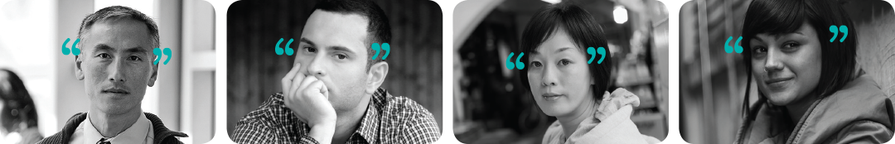



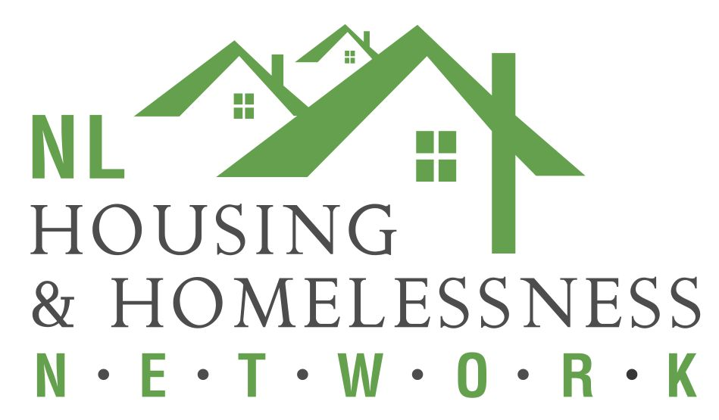

**Changing Minds Workshop**

**A Community Education Program about the Experience of Mental Illness**

**Date: November 18 and 19, 2019**

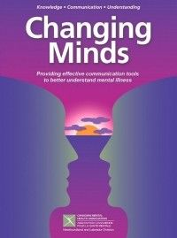

**Sponsored by:**



**Location: NLHHN**

**77 Charter Ave,**

**St. John’s**

**To register email bhaley@cmhanl.ca**

**Light Snacks and**

**Coffee provided**

**Limited seats available**

**The workshop will include:**

* **An in-depth understanding of mental illness from the perspective of those with lived experience**
* **Instructional modules on mental illness**
* **The connection between theoretical knowledge and individual experience**
* **A model for front-line intervention**

