

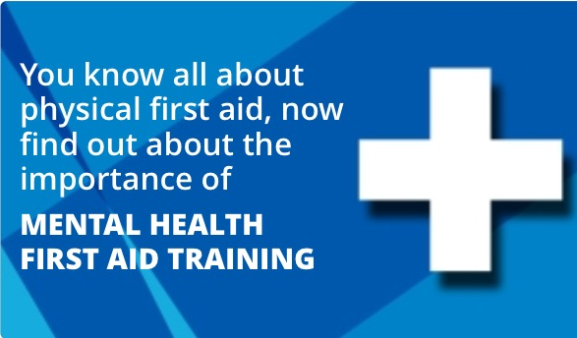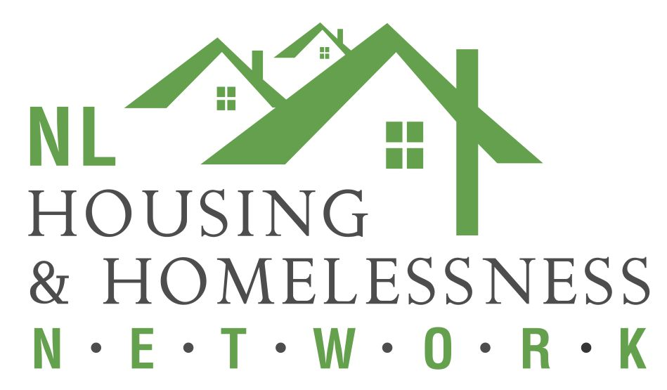



**November 25 and 26, 2019**

**Sponsored by:** 

**Time: 8:30 to 4:00**

**Location: NLHHN 77 Charter Ave, St. John’s**

**Light snacks, coffee and tea provided**

**Free parking across from Centre**

**To register email:** [**bhaley@cmhanl.ca**](mailto:bhaley@cmhanl.ca)

**This workshop will teach participants to:**

* **Recognize the signs and symptoms of mental health problems.**
* **Provide initial help.**
* **Guide a person towards appropriate professional help.**