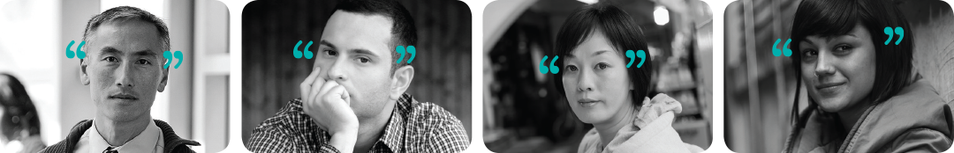

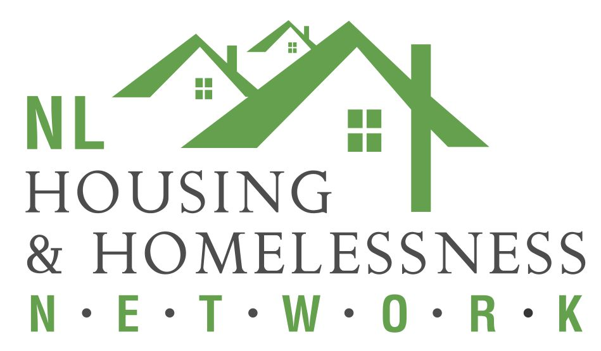

**Mental Health First Aid Workshop**

**Adults Who Interact with Youth**

**This course focuses on the basics of Mental Health First Aid, and more specifically on mental health problems and first aid for young persons aged 12 to 24.**

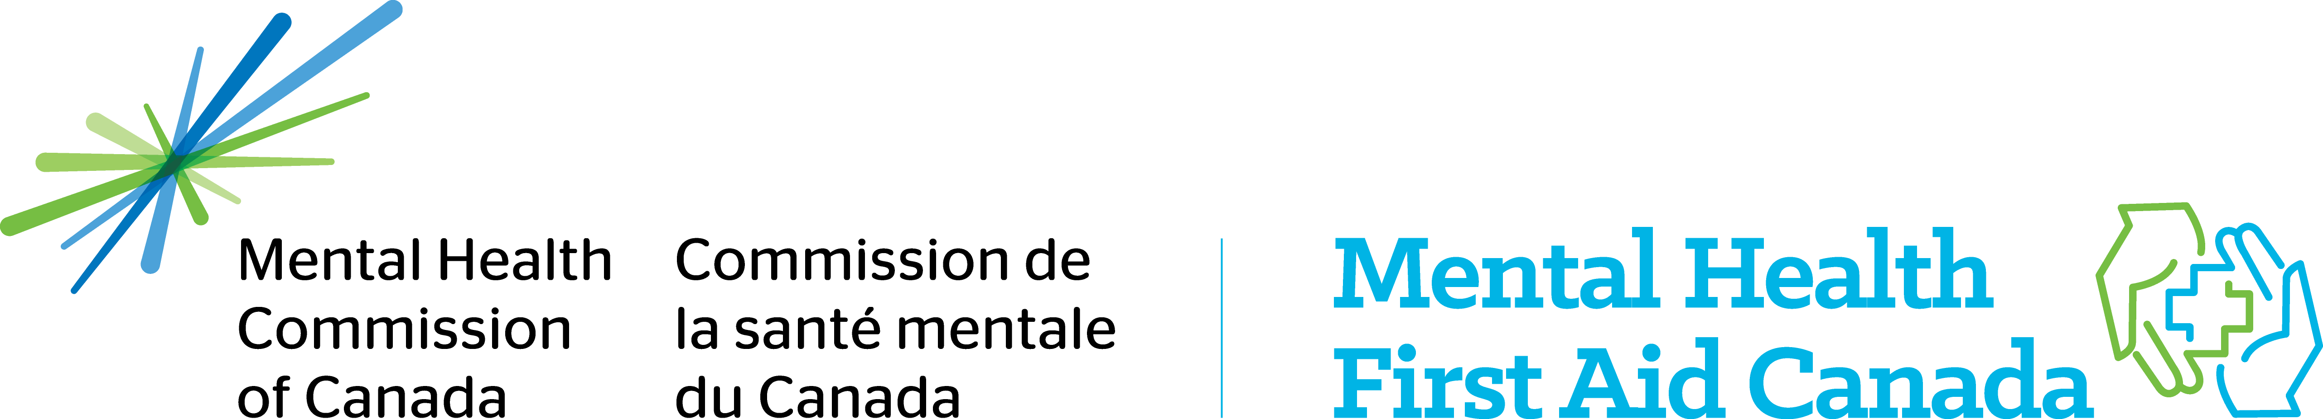

**The course is designed for Teachers, Social Workers, Counsellors, Law Enforcement, Coaches, Babysitters, First Responders, Healthcare Providers, Community Leaders, Parents and Family Members**.

**Date: Dec. 12 & 13, 2019**

**Sponsored by:**



**Time: 8:30 to 4:30**

**Location: NLHHN, 77 Charter Ave., St. John’s**

**Free parking available**

**Light snacks, coffee**

**and tea provided**

**To register email:** [**bhaley@cmhanl.ca**](mailto:bhaley@cmhanl.ca)

**This workshop will teach participants to:**

* **Recognize the signs and symptoms of mental health problems.**
* **Provide initial help when facing a mental health problem.**
* **Guide youth or adults towards appropriate professional help.**
* **Learn how to accommodate young people who are in distress.**