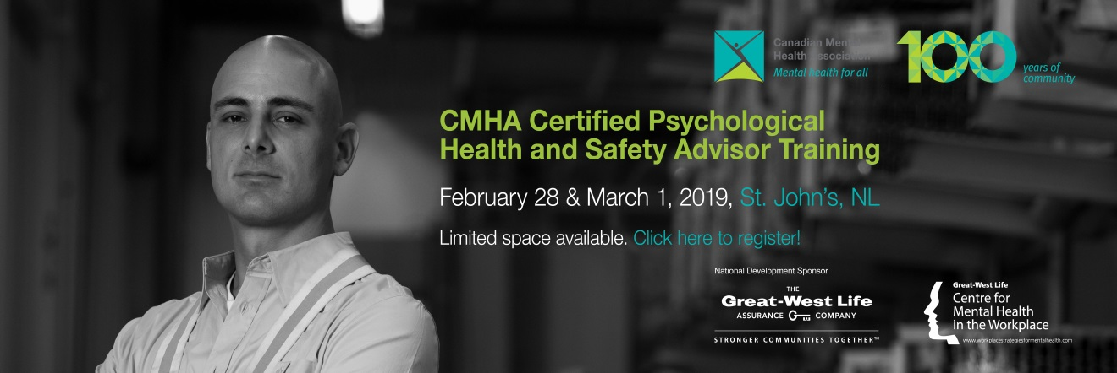

**Psychological Health and Safety Advisor Training**

|  |  |
| --- | --- |
| Name |  |
| Title |  |
| Organization/Company |  |
| Address |  |
| Phone |  |
| Email |  |

**Date: December 3 and 4, 2019**

**$1,000.00/person early bird rate before November 12th , 2019**

**$1,200.00 regular rate after November 12th.**

**Location: NLHHN 77 Charter Ave**

**Lunch, Light Snacks, Coffee, Tea and Refreshments Provided**

* Registration Deadline: **November 25th, 2019**
* Payment can be made in person at the CMHA-NL office, or by money order, cheque, or credit card. Money orders/cheques should be made out to CMHA-NL.
* Registration is not final until payment is received. No payments will be accepted day of.
* Cancellations cannot be made after the registration deadline.
* Substitute delegates will be welcome up to 48 hours before.
* If you require disability related supports or assistive devices for participation, please indicate below:

Credit card #:_________________________Expiration Date: ____________

Signature: ____________________________________________________

All questions can be directed to Bernice Haley at bhaley@cmhanl.ca

**Phone 709-753-8550 Ext 101, Fax 709-753-8537**